Improving Indoor Positioning Through Constraint Optimization – Project Proposal

Andrew Slater   
Biomedical Engineering  
University of ConnecticutStorrs, CT 06488  
andrew.slater@uconn.edu  
  
line 1: 2nd Given Name Surname  
line 2: *dept. name of organization (of Affiliation)*  
line 3: *name of organization (of Affiliation)*line 4: City, Country  
line 5: email address or ORCID*)*

*Abstract*—Fingerprinting is a well know method to improve indoor positioning. This method, however, requires a data collection process that includes physical measurement to determine ‘true’ locations. Taking physical measurements apriori is costly, time consuming, and in some cases impossible. This proposal defines a project that will use a novel approach to determine highly accurate ‘true’ locations without physical measurement. This is accomplished by adding a distance constraint to multiple tags moving simultaneously through the space. Using this known distance constraint, we aim to test to what degree true position information can be determined even in the absence of physical measurements.

Keywords—ips, indoor location, indoor location services

# Introduction

Indoor positioning is an important function critical to many industries: healthcare, manufacturing, distribution, retail, first responders. As a relatively new technology about to reach mainstream, many applications and benefits are yet to be discovered.

There are challenges with indoor positioning

* Consistent, reliable, sub-meter accuracy is difficult to obtain
* Inability to use GPS require use of other existing infrastructure or unreliable IMU based positioning
* Inaccuracy when using RSSI from WiFi Router
* Inconsistent signal information due to changing environment or user orientation results in inaccurate location

One method to improve accuracy is known as Fingerprinting. This method involves a set-up sequence which records the received signals at known ‘true’ locations. Then as new users traverse the space their received signals are computed against the recorded signals with known true locations, to calculate a better estimated position.

The problem with this method is the difficulty and time associated with measuring the known ‘true’ locations. Furthermore, because this effort is high, re-running the setup is difficult to do, although required as the environment changes. It also may not be possible to have access to the space for the setup process.

We plan to investigate a new method that implement dynamic fingerprint data collection. By having three tags at fixed distances to each other, an additional constraint is introduced into calculating a reasonable ‘estimated’ true position. This estimate will be used as the basis for fingerprint calculations further down the process and is not part of this research.

To collect data will set up an experiment to collect information from three tags at known fixed distance from each other, as we move through a space. We intend perform the following comparison to the known true location:

- Our estimated location based on three-tag constraint

- The vendors calculated location of each of the tags

If successful, the results of this study will be used in a UCONN Firefighter Partner Locator system implemented at UCONN. In this system, indoor coordinates are used to assist in providing navigation instructions to the firefighter. Better location information will result in better instruction which will inspire the user with a greater degree of confidence and potentially save lives.

Thesis:

* A 3-tag IPS method to collect indoor positioning data will provide constraints from which more accurate ‘true’ location can be determined without making any physical measurement.

The general data framework and activities for this project:

* Sensor deployment: Accurately measuring a space for anchor and ‘true’ location positions
* Data collection: run the experiment to collect the data
* Data evaluation: basic data analysis as described below
* Data preprocessing: filling missing values and filtering noise
* Simple Data Processing: location calculation using 3-tag constraints and comparison to vendors provided information and measured ‘truth’

The deliverables for this project:

* Project proposal class presentation – 10/21
* This document – by 10/24
* PowerPoint presentation – 12/6
* Written report – 12/6
* Class presentation – 12/6

# Related work or Survey

To organize our examination on the subject, take advantage of prior knowledge, and document how our solution is novel, we will survey at least 5 other papers in addition to the reference paper provided with this assignment

* UJIIndoorLoc: A New Multi-building and Multi-floor Database for WLAN Fingerprint-based Indoor Localization Problems [1]
* An Algebraic Solution to the Multilateration Problem [2]
* An Improved Geometric Algorithm for Indoor Localization [3]
* Trilateration in Indoor Positioning with an Uncertain Reference Point [4]
* Indoor Localization Approach Based on Received Signal Strength (RSS) and Trilateration Technique [5]
* Indoor Localization Method Based on Wi-Fi Trilateration Technique [6]

# Proposed directions of technical components:

Figure 1 below is a floor plan of the technical solution. We have designed an environment with precision located anchors using RTLOC indoor positioning anchors, and a 3-tag device to collect information. A python application will interface to the RTLOC system to collect information shown in example table below. We will also build a simple algorithm to use the 3-tag data to improve the calculation for the actual tag position and compare to a measured known true value.

##### 

Figure 1: Floor plan and anchors located at 1,2,3,4,8006

The information flow between the components is illustrated in Figure 2 and will be described in detail in the final paper and presentation.

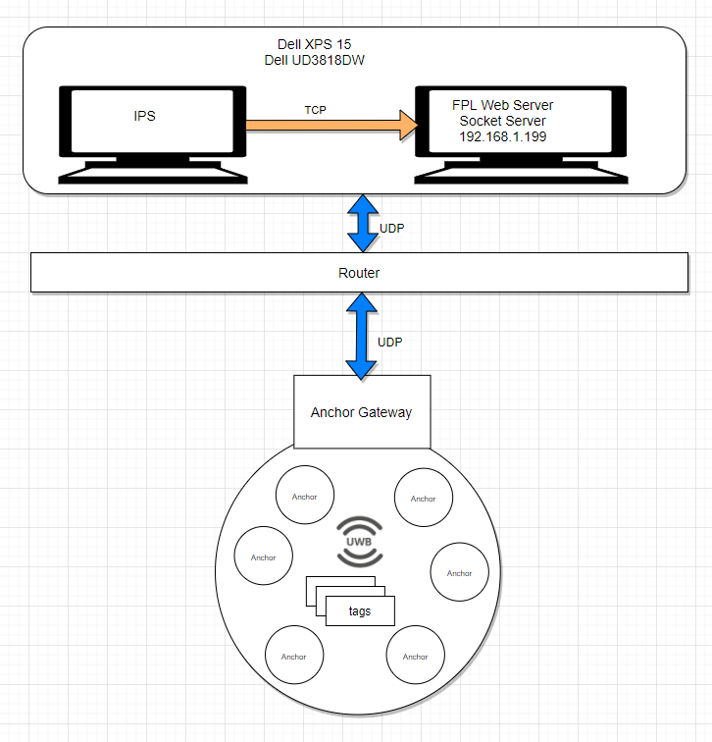

Figure 2 Anchor distances and tag location Information flow

# Dataset preparation and plan of experimental studies:

Figure 3 shows a representative snapshot of the dataset we will gather. Initial review shows inconsistencies in the collected data including time slots where an anchor does not report a distance to a tag, as well as timeslots where a tag is missing completely. We will use filling and filtering techniques to accommodate inconsistent data information.

##### 

Figure 3: Sample data set

In the table above, the marker field in the table indicates the anchor location where the tags are placed as shown in Figure 4 below.

The marker value is used to identify when a tag is in a known location. This can be set by the operator through the tool interface. For example when the maker value is 0, the tags will be in known location #1 (1597,1958). Tags are kept at a marked location for 30 seconds.

In the final report the statistical analysis will include the number of missing samples, average, and standard deviation of each tag at each marked location, as well as our computed location based on utilizing the known 3-tag constraint. Figure 5 shows (x,y) average and standard deviations over all markers and tags for the vendor computed location.

From the figure, average values are reasonably close for each of the 3 tags at each of the marker locations, however, the standard deviation swings significantly. We believe our solution will have an average value closer to the truth and that our standard deviation will be lower. In the final report similar charts will be prepared showing standard deviation values for anchor distances to tags for each location.

Figure 5 : (x,y) average and standard deviations over all markers and tags for vendor calculated positions

Root mean square distance error between the calculated values and the known location will be used to determine the error magnitude of each collection point for vendor calculated points, trilateralization, and our method for each of the five locations. The average and standard deviation of these values will be used to determine the accuracy and precision of the localization method.

Figure 6 shows the timeline for achieving our objectives.

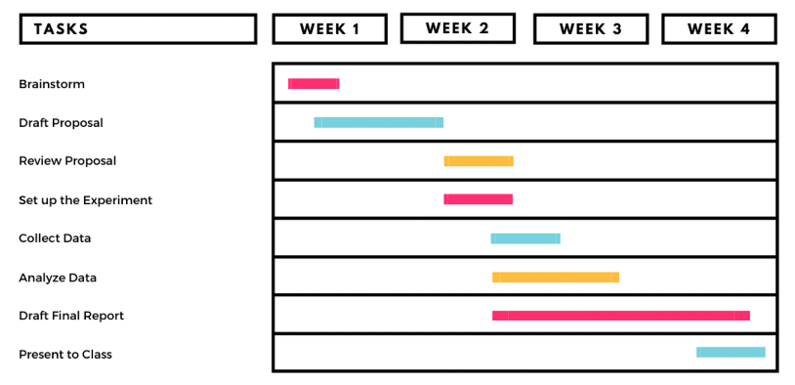

Figure 6: Activity plan

# Responsible Content:

This section will include the contributions from each student.

##### References

[1] J. Torres-Sospedra *et al.*, “UJIIndoorLoc: A new multi-building and multi-floor database for WLAN fingerprint-based indoor localization problems,” in *2014 International Conference on Indoor Positioning and Indoor Navigation (IPIN)*, Oct. 2014, pp. 261–270, doi: 10.1109/IPIN.2014.7275492.